Manager Tab:

Step 1: Click on the Manager Tab and login in with your windows credentials.

Step 2: If the reportees have filled the appraisal form, then it would show in the list as below.

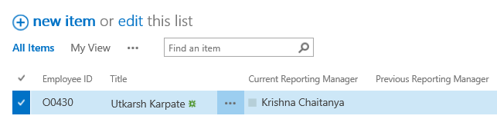

Step 3: Click on the ellipsis and look for an option ‘Edit’ option. Click on the ‘Edit’ option to view the form submitted by the reportees.

Machine generated alternative text:
@ new item or edit this list 
All Items My View 
V Emplcnjee ID Title 
Find an item 
p 
Current Reporting Manager 
Share 
Edit Item 
Delete Item 
View Item 
Advanced 
Previous Reporting Manager 
Utkarsh Karpate 

Step 4: The current reporting manager will have to fill the Feedback on Self-assessment and Feedback on Employee Goals.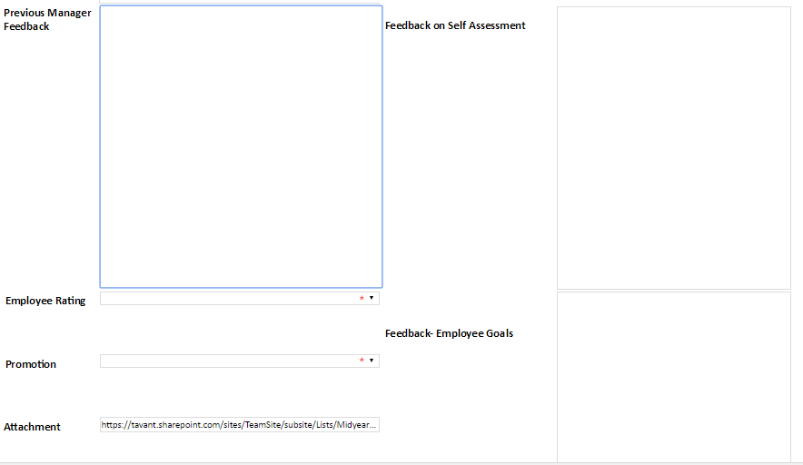

Step 4: The current Manager can forward the form to the previous reporting manager, by entering /selecting name from the people picker adjacent to. *[ The current reporting manager will have to inform the previous reporting manager].*



Step 5: The Current reporting manager will have to select the rating as per the data given below:

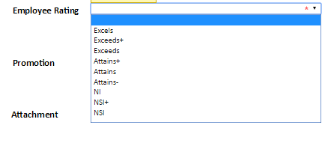

Step 6: Promotion Details should be selected from the drop down:

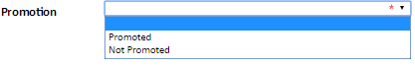

Step 7: The current Reporting Manager submits the form.